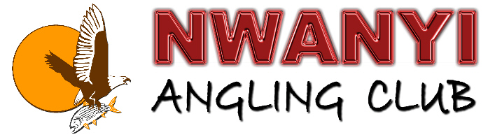
PO Box 384, Ngweze, Katima Mulilo, Namibia, 9000
+264 811 248 210 (Chairperson) • +264 811277429 (PRO)
nwanyi@caprivi.biz • www.caprivi.biz/nwanyi.html

2013 ZAMBEZI INTERNATIONAL CLASSIC INDEMNITY FORM
ANGLER 1

I………………………………………………………………………… the undersigned herewith declare that I will not hold the organizers, sponsors, camp staff or camp owners in any way responsible for any loss, damage or injury incurred by me during this angling competition.

Signature…………………………… Date:……………………

ANGLER 2

I………………………………………………………………………… the undersigned herewith declare that I will not hold the organizers, sponsors, camp staff or camp owners in any way responsible for any loss, damage or injury incurred by me during this angling competition.

Signature…………………………… Date:……………………

ANGLER 3

I………………………………………………………………………… the undersigned herewith declare that I will not hold the organizers, sponsors, camp staff or camp owners in any way responsible for any loss, damage or injury incurred by me during this angling competition.

Signature…………………………… Date:……………………

We hereby acknowledge that we read and understood the rules for the Zambezi International Classic 2013.

Signature

..................................................
Captain

!!!!! RIGHT OF ADMISSION RESERVED !!!!!

